Date:

Participant’s Name: _________________________
Participant’s Street Address: _________________________________________
Participant’s City, ST, Zip: _________________________________

CERTIFICATE OF GOOD HEALTH / HEALTH EXAMINATION REPORT

To whom it may concern,

This letter is to inform you that the above-mentioned participant is part of the humanitarian medical and dental outreach trip to Zambia in August 2022. After reviewing their application, Global Health Outreach has accepted this person to join our team.

Their personal physician’s signature below attests that as of their most recent physical exam they are in good physical and mental health and do not have any communicable diseases.

Thank you for your gracious consideration of this participant.

Sincerely,
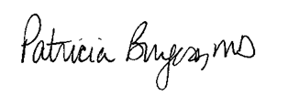
Patricia Burgess, MD
Director, Global Health Outreach

Concurring Personal Physician’s Signature: __________

Physician’s Name: _________________________ _____________ ____ _
Office Address: _________________ ________________ _________
Office Phone: _________________________________________________ _ _

